Task 1 — Exploratory Data Analysis and Preprocessing

1.1 Dataset overview and exploratory analysis
The purpose of this exploratory data analysis (EDA) is to understand the characteristics of the kick_1 dataset, identify quality issues, and investigate relationships between variables. This understanding will also contribute to identifying preprocessing requirements before machine learning modelling begins.
Dataset name | Kick_1
Source | List of Variables (2026), courtesy of Professor Richi Nayak, School of Computer Science, QUT
Number of observations | 41,476
Number of variables | 31
Target variable | IsBadBuy (1 = Bad Buy/Kick, 0 = Not Bad Buy)

Dataset Overview
Initial inspection showed a mixture of numerical and categorical variables. Several MMR price variables were imported as text/object values rather than numeric values, indicating that invalid or non-numeric entries required investigation before modelling.

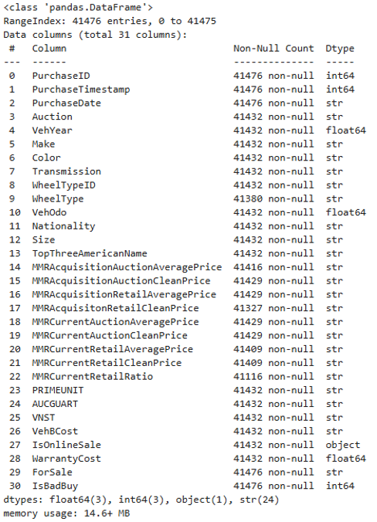
Figure 1-1: Initial data type query of kick_1.csv data frame
Table 1-1: Summary of data types contained in kick_1.csv
DATA Type | Result
discrete (integer) | 3
continuous (float) | 3
String | 24
OBJECT (GROUP) | 1

Data Exploration
Our team explored the dataset to understand its structure, the variables, data types, distribution and overall quality prior to commencing preprocessing. This activity involved:
- Identifying missing or unusual variables
- Reviewing variable distributions and unique values
- Discovering and reviewing potential outliers
- Comparing related or similar variables for possible redundancy exclusion
- Examining the distribution of the target variable IsBadBuy
These findings were used to inform future data processing and variable selection activities.

Key Data-Quality Findings
Table 1-2: Summary key findings contained in kick_1.csv during EDA
VARIABLE / ISSUE | KEY FINDING | IMPLICATION
Missing observations | A recurring group of 44 observations consisted of missing values across many unrelated variables. This may suggest record corruption  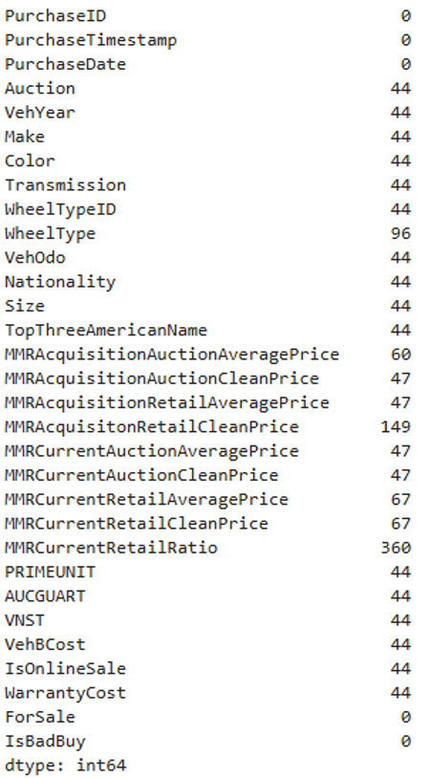 | These observations represented a fractional population of the overall variables size and contained little predictor information.  Outcome: These were later removed during pre-processing.
PRIMEUNIT / AUCGUART | Approximately 96% of observations contained unknown (?) values.  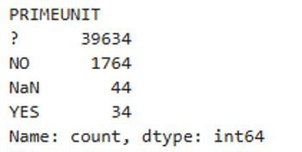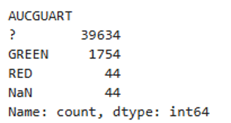  Imputation was not considered a viable option as the model would have significantly depended on data had been estimated rather than observed. | As approximately 96% of the values were unknown, too little valid information remained for these variables could be used to reliably contribute to predicting IsBadBuy  Outcome: These were later removed during pre-processing.
WheelTypeID / WheelType | Cross-tabulation showed that the two variables represented substantially the same wheel-type information.  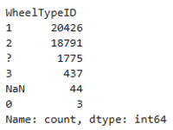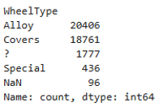  Shows that WheelTypeID is very likely the numeric code for WheelType. They may be two representations of the same feature, which is supported by in the assignment. One of these variables may potentially be a redundant variable. Without assuming, cross tab validation was used to compare two categorial variables and count how often each combination occurs.  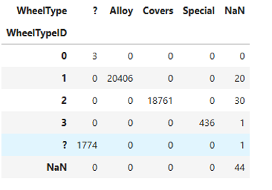  This shows that 20406 cars with WheelTypeID = 1 have WheelType = Alloy, similar mapping exists for Covers and Special. There a very clear mapping can be observed. | This finding indicated redundancy between the variables as they contained the same information in different representations. Cross Tab demonstrates that WheelTypeID and WheelType are essentially duplicate representations of the same information.  Outcome: Remove WheelTypeID as it contained numeric identifiers.
Transmission | The categorical values MANUAL and Manual represented the same transmission type but used inconsistent capitalisation | The values were standardised to uppercase so that MANUAL and Manual were treated as a single MANUAL category rather than two separate categories.  Outcome: standardise Transmission variable during pre-processing
Each observation had a unique PurchaseID | Each observation had a unique PurchaseID | This confirms that this variable is just an identifier and every unique observation does not help in identifying if a vehicle is a bad buy risk.  Outcome: Exclude PurchaseID during pre-processing
ForSale | The variable was effectively constant after accounting for inconsistent capitalisation of Yes.  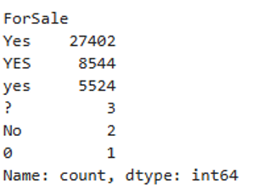 | The sum of all Yes, YES and yes observations is 41470 which represents 99.99% of the dataset. As the predictor needs variation to classify an outcome as a “Bad Buy”, it cannot split or classify the data. We can exclude ForSale due to non-near zero variance.  Ouctome: Exclude ForSale during pre-processing
PurchaseTimestamp / PurchaseDate | Both represented the same purchase-time information in different formats. Comparison of variables for the first 20 outputs without duplicates yields:  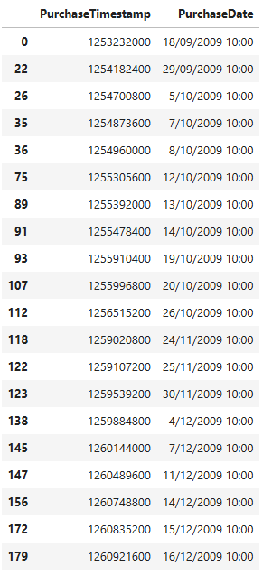  Variables PurchaseTimeStamp and PurchaseDate may have potential redundancies this is evidenced by observing the first rows which shows PurchaseTimestamp PurchaseDate 1253232000 18/09/2009 10:00. | This output shows that the purchase time information is represented in two formats. PurchaseDate is easier to interpret and will be highlighted to keep.  Outcome: Exclude PurchaseTimestamp and retain PurchaseDate as it is more interpretable.
MMR valuation variables | Several fields contained systematic 0/1 or non-numeric values inconsistent with genuine vehicle prices. The MMR variables were converted to numeric values. The non-numeric NaN values were converted to missing values. Invalid numeric values such as ? Were repalced with NaN. This allowed the missing values to be imputed.  The list of MMR affected are:  - MMRAcquisitionAuctionAveragePrice  - MMRAcquisitionAuctionCleanPrice  - MMRAcquisitionRetailAveragePrice  - MMRAcquisitonRetailCleanPrice (note the dataset's spelling of “Acquisiton”)  - MMRCurrentAuctionAveragePrice  - MMRCurrentAuctionCleanPrice  - MMRCurrentRetailAveragePrice  - MMRCurrentRetailCleanPrice  - MMRCurrentRetailRatio  The invalid and missing values in each of these MMR variables were imputed using the median characteristic. The median was selected because MMR variables extreme outlier vehicle price values that could skew mean to the right if chosen. As the median is less senstitive to outliers, it is a more appropriate choice. | MMR Variables required cleaning and imputation before modelling.  Outcome: Imputed total number of missing MMR observations by observing the statistical distribution
Color/Nationtionality/Size | Most observations contained valid colour categories; however, NOT AVAIL and ? both represented unavailable colour information. | These were standardised into a single UNKNOWN category so the observations could be retained. The ? values were changed to UNKNOWN. Other categories were retained because there was insufficient evidence to combine them.  Outcome: standardise these variables during pre-processing
VehBCost | 29 observations contained invalid ? Values.  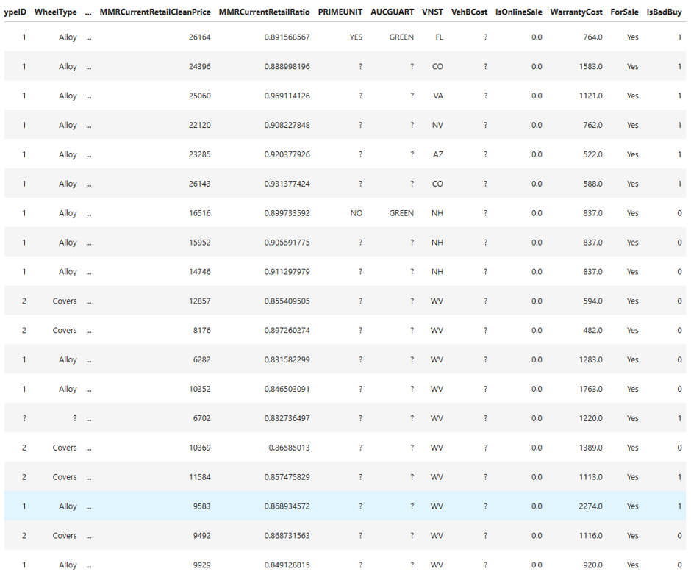  29 represents a fractional proportion of observations so the data can be imputed statistically. | Outcome: VehBCost was converted to numeric and the 29 missing values (~0.07%) were imputed using the median of $6,710, which was less sensitive to extreme values.
IsOnlineSale | This variable is data type “object” which pandas flagged earlier as containing multiple mixed types.  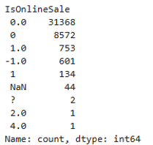  The IsOnlineSale variable was expected to be binary, where 0 represents a non-online sale and 1 represents an online sale. However, value_counts() identified several unexpected values, including -1.0, 2.0, 4.0, ?, and missing values.  The values 0 and 0.0 appear to be the same category, as do 1 and 1.0. The remaining values fall outside the documented binary categories and were therefore treated as invalid rather than assuming their intended meaning.  The meaning of -1.0 could not be established from the available documentation, so it was not recoded as 1 because this would introduce an unsupported assumption. It was treated as a invalid value that would be imputed in the future.  Instead, invalid values were treated as missing and subsequently imputed using the mode (0), which was the dominant valid category. | Values were observed outside the binary categories, which suggests a data quality issue. Categories outside this range were classified invalid as they could not be reliably categorised. The variation in 0 and 1 showed sufficient variation for IsOnlineSale to be retained as a useful predictor.  Outcome: Convert invalid values –1.0, 2.0, 4.0 and ? Into NaN. Then impute NaN to enable the predictor to be retained for modelling.
IsBadBuy | Approximately 87.05% of observations were Not Bad Buy and 12.95% were Bad Buy | The target variable is imbalanced and this needs to be considered when evaluating model performance. Therefore, when splitting the dataset into test and training data sample populations, both data sets need to be stratified as preserve the original populations.

1.2 Variable selection and preprocessing
Following EDA, the initial set of 31 variables were either excluded or retained depending on their role, quality of data and value associated with being a predictor for IsBadBuy.

Retained Variables
Categorical variables that described characteristics of the vehicle, auction and purchase process that could potentially contribute to predicting whether a vehicle was a bad buy. Although IsOnlineSale and IsBadBuy were numerically coded as 0 and 1, they were treated as nominal binary variables because the values represented categories rather than numerical quantities. IsBadBuy was assigned the target role because predicting a Kick was the objective of the modelling task.
Table 1-3: Retained Categorial Variables
VARIABLE | ROLE | MEASUREMENT LEVEL | JUSTIFICATION
Auction | Input | Nominal | Identifies the auction provider and may capture differences between auction sources.
Make | Input | Nominal | Identifies the vehicle manufacturer and may be associated with the likelihood of a bad buy.
Color | Input | Nominal | Represents vehicle colour as unordered categories.
Transmission | Input | Nominal | Distinguishes transmission types such as automatic and manual.
WheelType | Input | Nominal | Identifies the vehicle's wheel type as unordered categories.
Nationality | Input | Nominal | Groups vehicles according to manufacturer nationality/category.
Size | Input | Nominal | Represents vehicle size categories such as compact, medium and large.
VNST | Input | Nominal | Identifies the US state associated with the vehicle purchase.
IsOnlineSale | Input | Nominal (binary) | Indicates whether the vehicle was purchased online (1) or not (0).
IsBadBuy | Target | Nominal (binary) | Indicates whether the purchased vehicle was a Kick/bad buy (1) or not (0).

Numerical variables describing vehicle age, usage, acquisition cost, warranty cost and market valuations because these characteristics could reasonably contribute to identifying potential bad buys were retained. Monetary, odometer and MMR measures were treated as ratios, while vehicle year and purchase date were treated as interval measures.
Table 1-4: Retained Numerical Variables
VARIABLE | ROLE | MEASUREMENT LEVEL | JUSTIFICATION
PurchaseDate | Input | Interval | Contained variation which may capture time-related changes in market and auction conditions.
VehYear | Input | Interval | Contained variation which may capture age-related differences associated with Bad Buy risk.
VehOdo | Input | Ratio | Contained variation which may reflect vehicle usage, condition and Bad Buy risk.
MMRAcquisitionAuctionAveragePrice | Input | Ratio | Sufficient variation which may help identify Bad Buy risk.
MMRAcquisitionAuctionCleanPrice | Input | Ratio | Sufficient variation which may help identify Bad Buy risk.
MMRAcquisitionRetailAveragePrice | Input | Ratio | Sufficient variation which may help identify Bad Buy risk.
MMRAcquisitonRetailCleanPrice | Input | Ratio | Sufficient variation which may help identify Bad Buy risk.
MMRCurrentAuctionAveragePrice | Input | Ratio | Sufficient variation which may help identify Bad Buy risk.
MMRCurrentAuctionCleanPrice | Input | Ratio | Sufficient variation which may help identify Bad Buy risk.
MMRCurrentRetailAveragePrice | Input | Ratio | Sufficient variation which may help identify Bad Buy risk.
MMRCurrentRetailCleanPrice | Input | Ratio | Sufficient variation which may help identify Bad Buy risk.
MMRCurrentRetailRatio | Input | Ratio | Sufficient variation which may help identify Bad Buy risk.
VehBCost | Input | Ratio | Contained variation in acquisition cost that may help identify financially unfavourable vehicle purchases.
WarrantyCost | Input | Ratio | Contained variation in warranty cost that may reflect differences in expected vehicle risk.

Excluded Variables
Variables that were classified as identifiers or redundant with retained variables, contained insufficient usable information, or showed near zero variation were excluded. Where two variables represented similar information, the more interpretable or detailed variable was retained. This reduced unnecessary inputs while preserving variables that could reasonably contribute to predicting IsBadBuy.

Table 1-5: Retained Numerica Variables
VARIABLE | ROLE | JUSTIFICATION
PurchaseID | Excluded | Unique identifier that does not describe a vehicle characteristic and was not considered meaningful for prediction
PurchaseTimestamp | Excluded | Contained redundant purchase-time information already represented by the more interpretable PurchaseDate
WheelTypeID | Excluded | Coded representation of WheelType; cross-tabulation showed the variables contained redundant information
TopThreeAmericanName | Excluded | Broad manufacturer grouping that overlapped with the more detailed information retained in Make
PRIMEUNIT | Excluded | Approximately 95.6% of values were unknown (?), leaving insufficient usable information
AUCGUART | Excluded | Approximately 95.6% of values were unknown (?), leaving insufficient usable information
ForSale | Excluded | Almost all observations represented Yes, resulting in near-zero variation and little potential predictive information

1.3 Dataset Before and After Preprocessing
The figure below illustrates the dimensional transformation of the kick_1.csv dataframe after preprocessing.
Figure 1-2: Dataset processing before and after preprocessing
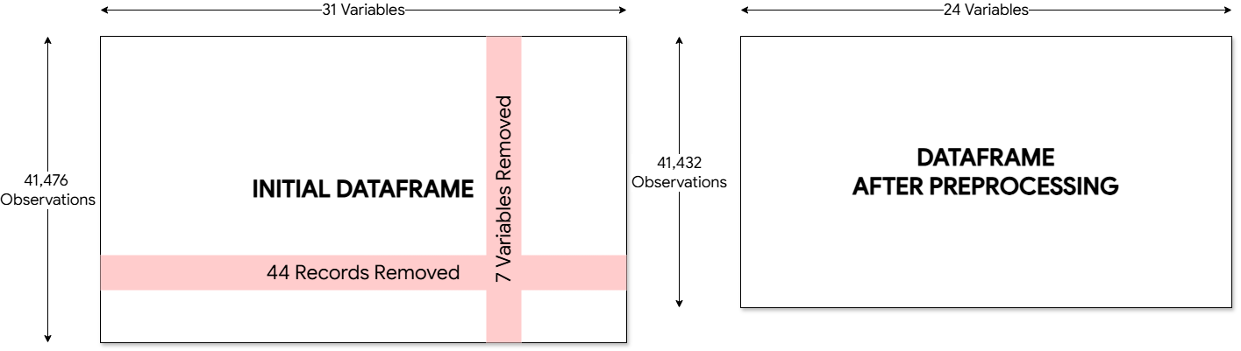

1.3 Target Distribution After Preprocessing
The target variable’s (IsBadBuy) binary nominal distribution was compared before and after pre-processing. Bad buys represented approximately 12.95% of observations both before and after preprocessing, indicating that removal of the 44 highly incomplete observations did not materially alter the target distribution. The target was substantially imbalanced, with approximately 87% non-bad buys and 13% bad buys, which should be considered when evaluating subsequent classification models.
Table 1-6: Target variable before and after preprocessing distribution
ISBADBUY | BEFORE PREPROCESSING | AFTER PREPROCESSING
0 — Not bad buy | 36,105 (87.05%) | 36,067 (87.05%)
1 — Bad buy/Kick | 5,371 (12.95%) | 5,365 (12.95%)
Total | 41,476 | 41,432

Dataset Overview

The dataset contains both numerical and categorical values. Several price related variables have been imported as object instead of float64 which may indicate quality issues with the data.

Data Quality Assessment

3.1 Missing values
Most variables have missing values; however, none of the variables are missing more than 0.87%. Several variables appear to be missing the same number of values, which will require consideration during the data-cleaning stage.
Item | Variable | Missing Values | Percentage Missing
1 | MMRCurrentRetailRatio | 360 | 0.87
2 | MMRAcquisitonRetailCleanPrice | 149 | 0.36
3 | WheelType | 96 | 0.23
4 | MMRCurrentRetailCleanPrice | 67 | 0.16
5 | MMRCurrentRetailAveragePrice | 67 | 0.16
6 | MMRAcquisitionAuctionAveragePrice | 60 | 0.14
7 | MMRAcquisitionAuctionCleanPrice | 47 | 0.11
8 | MMRCurrentAuctionAveragePrice | 47 | 0.11
9 | MMRAcquisitionRetailAveragePrice | 47 | 0.11
10 | MMRCurrentAuctionCleanPrice | 47 | 0.11
11 | Size | 44 | 0.11
12 | Nationality | 44 | 0.11
13 | VehOdo | 44 | 0.11
14 | WheelTypeID | 44 | 0.11
15 | Color | 44 | 0.11
16 | Transmission | 44 | 0.11
17 | Make | 44 | 0.11
18 | VehYear | 44 | 0.11
19 | Auction | 44 | 0.11
20 | TopThreeAmericanName | 44 | 0.11
21 | PRIMEUNIT | 44 | 0.11
22 | AUCGUART | 44 | 0.11
23 | VNST | 44 | 0.11
24 | VehBCost | 44 | 0.11
25 | IsOnlineSale | 44 | 0.11
26 | WarrantyCost | 44 | 0.11

Duplicates
None of the variables appear to be full duplicates. There is a recurring count of 44 missing entries across unrelated columns (Auction, VehYear, Make, Color, Transmission, etc.), which strongly suggests systemic record corruption. Removing these 44 records during data cleaning will resolve over half of the missing variables across the dataset.

Target Variable
The target variable, IsBadBuy, represents 13 % (12.95 %) of the total outcomes which suggests, there is either a bias in the dataset or there is a better target variable. With only 13 % of the data being a IsBadBuy, there is a chance that even a bad model could be right 87 % of the time.

Summary Statistics
Summary statistics were calculated for variables which were initially identified as numerical. The variables which were incorrectly imported as object data types will require further investigation and conversion before further numerical analysis. Variables that perhaps should have been imported as objects will also require further investigation.
 | PurchaseID | PurchaseTimestamp | VehYear | VehOdo | WarrantyCost | IsBadBuy
count | 41476 | 4.15E+04 | 41432 | 41432 | 41432 | 41476
mean | 20737.5 | 1.26E+09 | 2005.36 | 71300.01 | 1273.05 | 0.13
std | 11973.23 | 1.80E+07 | 1.73 | 14724.04 | 599.19 | 0.34
min | 0 | 1.23E+09 | 2001 | 577 | 462 | 0
25% | 10368.75 | 1.25E+09 | 2004 | 61578 | 834 | 0
50% | 20737.5 | 1.26E+09 | 2005 | 73128.5 | 1155 | 0
75% | 31106.25 | 1.28E+09 | 2007 | 82259.25 | 1623 | 0
max | 41475 | 1.29E+09 | 2010 | 480444 | 7498 | 1

Unique Values
There are some amounts of values that appear to that will require further investigation such as IsOnlineSale (6) Auction (3) and Transmission (4). Other unique values do not seem to have a matching corresponding value in another column which it may make sense for it to be paired, MMMRA data.
Item | Variable | Unique Values
0 | PurchaseID | 41476
1 | VehOdo | 28604
2 | MMRCurrentRetailRatio | 25870
3 | MMRAcquisitonRetailCleanPrice | 11583
4 | MMRCurrentRetailCleanPrice | 11363
5 | MMRAcquisitionRetailAveragePrice | 11070
6 | MMRCurrentRetailAveragePrice | 10935
7 | MMRAcquisitionAuctionCleanPrice | 10010
8 | MMRCurrentAuctionCleanPrice | 9890
9 | MMRAcquisitionAuctionAveragePrice | 9271
10 | MMRCurrentAuctionAveragePrice | 9183
11 | VehBCost | 1869
12 | PurchaseTimestamp | 497
13 | PurchaseDate | 497
14 | WarrantyCost | 271
15 | VNST | 31
16 | Make | 30
17 | Color | 17
18 | Size | 13
19 | VehYear | 10
20 | Nationality | 6
21 | ForSale | 6
22 | IsOnlineSale | 6
23 | WheelTypeID | 5
24 | TopThreeAmericanName | 5
25 | WheelType | 4
26 | Transmission | 4
27 | Auction | 3
28 | AUCGUART | 3
29 | PRIMEUNIT | 3
30 | IsBadBuy | 2

Checking Text Anomalies

The Manheim Market Report (MMR) sets the indandustry standard for wholesale vehicle valuation, drawing on an extensive and precise database of transactional data from millions of Manheim vehicle auctions across the U.S. and Canada. MMR gives buyers and sellers the confidence to make informed business decisions (MMR, 2026).

Task 2 — Decision Tree Modelling

2.0 Model preparation
Df_model = df_processed.drop(["PurchaseDate"], axis=1).copy()
To create a modelling dataframe, PurchaseDate was removed as it was not possible to use datetime values (contained within PurchaseDate) in the Decision tree. Additionally, the practical modelling process requires numerical inputs, so there was no way to represent date information in the decision tree model.
Df_model = pd.get_dummies(df_model)
One-Hot-Encoding (OHE) was then used to transform the categorical predictor variables into binary numerical features so that it could be used in the Decision tree model. OHE transformed the categorical predictor variables into binary numerical features that could be used in the Decision tree model. As a result, it added 121 columns to the modeling dataframe as there were 121 categories that needed to be represented in multiple binary columns.
The modelling dataset was then separated into the target (y) and predictor features (X). IsBadBuy was used target since the goal of the model is to classify vehicles as either a Bad Buy or a non-Bad Buy. Feature names were retained for future use of the Decision tree and the predictor data was converted to a numpy array.
The decision was made to split the data into 70% training and 30% testing data subsets by setting a value of 0.3 for test_set_size. This was considered a suitable initial split metric as it allowed most of the data to be used for model development and still have enough unseen data to evaluate the models' effectiveness. Since random_state was defined as 10, it would ensure that the same randomisation sequence was followed thus making it reproducible.
Given that the target variable was unbalanced based on the previous task's preprocessing results, stratification was required performed to maintain approximately the same proportion of isbadbuy = 1 and isbadbuy = 0 observations within the training and test datasets. Following data partitioning, it was determined whether each observation within X had a corresponding observation within y and if the data remained properly aligned.
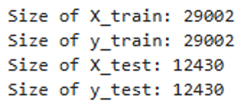
Following the correct 70/30 split between the training and test sets, it was confirmed that there were 29,002 observations within the training set and 12,430 observations within the test set.
To confirm that class distributions were maintained following stratification, normalised count values were compared for the target variable (IsBadBuy) in both the training and test datasets.
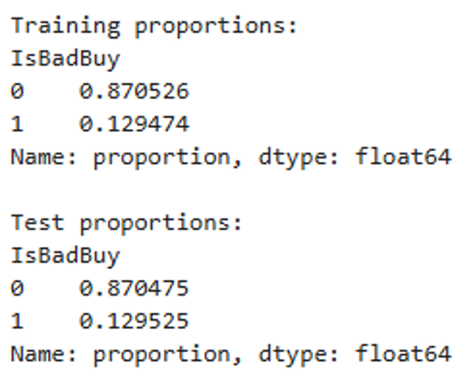
The above output shows that both proportions were consistent with those found within the original target distribution. Thus, stratification successfully preserved class distributions throughout both datasets.

Task 2.1(A) - What parameters have been used to build the tree? Detail them.
A Decision tree classifier was created using Default hyperparameters as a base model to establish a starting point for further comparison. The model was developed using the training dataset (x_train and y_train). Random_state = 10 was again used to enable reproducibility and consistency with prior practical exercises.
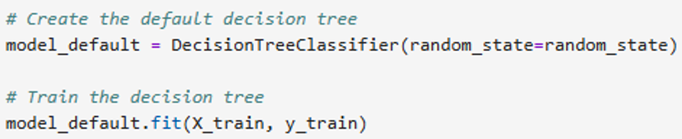
Decision trees have many model parameters that can affect their size and construction. The following command was executed to examine the default model parameters: 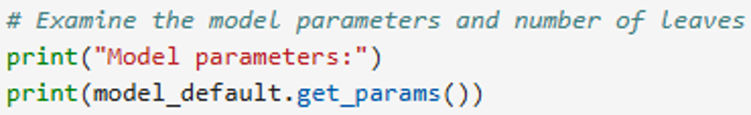
The default model parameters obtained from the code output are summarised in the table below.
Parameter | Value | Description
criterion | gini | uses Gini impurity value to determine quality of split
splitter | best | Determines best available split at each node
max_depth | None | No maximum depth indicates that the tree is allowed to grow until other stopping conditions are reached
min_samples_split | 2 | At least two observations to split internal nodes
min_samples_leaf | 1 | Leaf node can contain minimum of one observation
max_features | None | Can consider all possible features when searching for best split
max_leaf_nodes | None | No maximum number of terminal leaves specified
min_impurity_decrease | 0.0 | Must find improving split beyond meeting valid reduction threshold in impurity
min_weight_fraction_leaf | 0.0 | Must have minimum weighted fraction of samples within leaves
class_weight | None | Does not apply additional weighting to either target classes
ccp_alpha | 0.0 | Does not perform cost complexity pruning
monotonic_cst | None | Does not constrain monotonic relationships between any variables
random_state | 10 | Seed used to make model reproducible

Task 2.1(B): What data split was used to create training and test datasets?
The dataset was divided into 70 % training data and 30 % test data to provide sufficient observations for model development while providing a substantial independent dataset for evaluating model performance. The relatively large test sample set (~12,400) allowed for model performance to be assessed with greater confidence.
The dataset was imbalanced with approximately 13 % of observations representing bad buys in the IBadBuy variable. A substantial independent test set allows more bad buys to be identified with the model. A split of 80 % training and 20 % test sets (~8,300) would have reduced the test number of bad buys by approximately 500 observations reducing confidence levels.

Task 2.1(C): classification accuracy on the training and test datasets
Classification accuracy of the default decision tree was measured using both the training and test datasets. Comparison of classification accuracy on both datasets is useful for assessing whether model learned patterns within training data effectively and whether model performs similarly well on unseen test data.
Accuracy was calculated by calling .score() on the training and test datasets separately. Training accuracy measures how accurately model fit to training data. Test accuracy assesses how accurately model predicts unseen data. Both metrics provide insight into potential model overfitting issues.
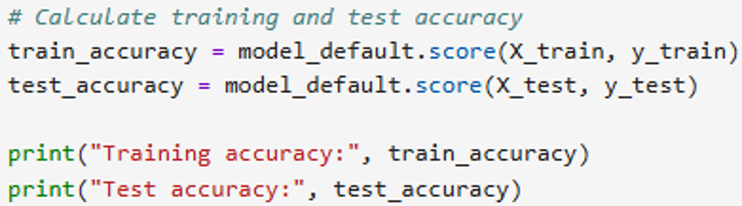
The code was executed and yielded:
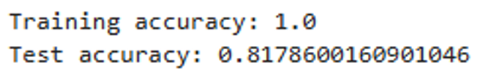
The default decision tree reported a training accuracy of 100%, but a test accuracy of 81.79%. As noted earlier, perfect training accuracy suggests that model correctly classified every single record within the training dataset. Approximately an 18.21% decrease occurred however when applying the model to unseen test records. The significant drop off between training accuracy and test accuracy strongly suggests that the Default Decision tree is fitting too close to the training data and therefore is likely overfitting. Overfitting is a common result of models with low bias and high variance. Models with low bias fit very well to training data due to extreme closeness in fit, therefore produce minimal errors in prediction when predicting against training data (low train error). However, models with high variance tend to vary greatly with even slight variations in input data and therefore predict poorly when tested against new/unseen data.

Task 2.1(D): What is the size of the tree (number of nodes and rules)
The size and complexity of the default decision tree was analysed by identifying the total number of nodes, number of leaf nodes and number of decision rules. The total number of nodes was retrieved via tree_.node_count which counts all nodes including internal decision nodes and leaf nodes in the fitted tree. Number of leaf nodes were retrieved using get_n_leaves().
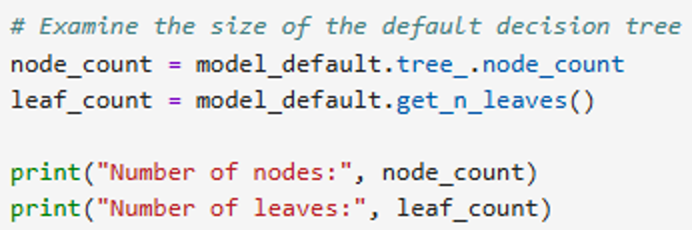
The output this executed code yields:
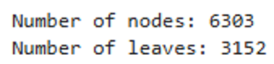
There were 6,303 total nodes in the decision tree with 3,152 being leaf nodes. Every leaf corresponds to one classification rule that defines an end-of-path from root node down to leaf node for a particular vehicle. Therefore, every root-to-leaf path may define one decision rule and conversely every decision rule ends in precisely one leaf node.
As a result, each leaf node defines one Decision rule and vice versa, establishing a one-to-one correspondence between paths down the tree . This demonstrated that the default decision tree is complex as evidenced by its large number of nodes and decision rules and is consistent with it having been allowed to grow without limits as indicated by its unlimited depth hyperparameter as well as evidence of overfitting presented by large difference between training and test accuracies.

Task 2.1(E): Which variable is used for the first split, and which variables are used for the second split?
The upper parts of the decision tree were analysed where first and second splits occur along with each of the two branches from first splits. With 6,303 nodes present in entire tree, a decision was made to only plot the top-most elements of tree sufficient for interpretation by using plot_tree() with max_depth=2.
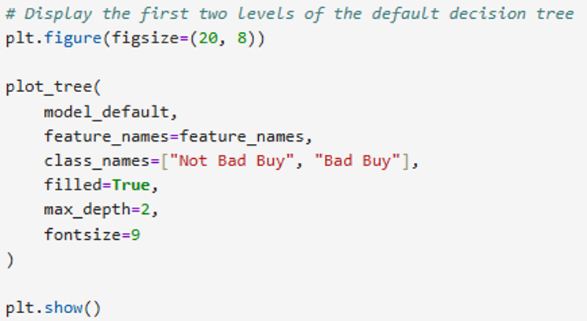
The resulting code output yields the following decision tree.
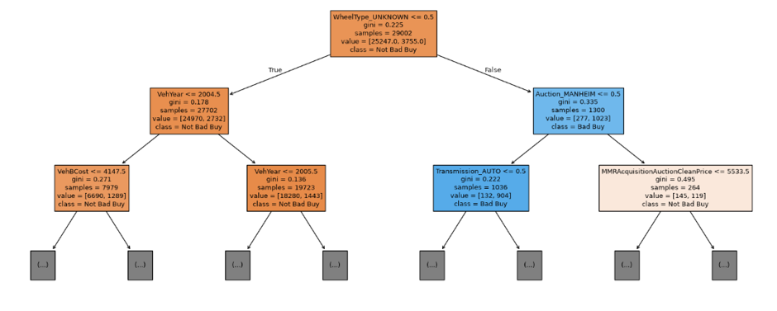
The default decision tree generated by algorithms chose WheelType_UNKNOWN as the first split variable using a threshold of 0.5. There were no specific manual decisions made regarding selection of variables/thresholds for splitting. During training, the algorithms searched among all candidate features to find split(s) that resulted in largest reduction in Gini impurities (i.e., largest increase in homogeneity).
WheelType_UNKNOWN was the variable used for the first level split and is a binary OHE feature. A threshold of 0.5 identifies vehicles that have wheel types documented (WheelType_UNKNOWN = 0) vs. Vehicles whose wheel types are unknown (WheelType_UNKNOWN = 1). Vehicles that meet first condition (wheel type is documented) take left branch after splitting; vehicles that don't meet first condition (wheel type is unknown) take right branch after splitting.
after the first split, the algorithm created second level splits on each branch from the first split. For vehicles whose wheel types are known, the algorithms chose VehYear as second level split variable with a threshold of 2004.5. For vehicles whose wheel types are unknown, the algorithm chose Auction_MANHEIM as second level split variable with a threshold of 0.5. Therefore, like first level splits, second level splits were chosen automatically by algorithms during training instead of being manually selected.
Each node in the default tree displayed information such as splitting condition, Gini impurity measure, sample count (n), distribution of target class values (value), and majority class label (class). Less intense colours indicate less homogeneous mixtures of classes; stronger colours indicate more homogeneous mixtures of classes. Orange colour indicates classification as closer to IsBadBuy = 0; blue colour indicates classification closer to IsBadBuy = 1.

Task 2.1(F): What are the five important variables in building the tree?
To determine which five attributes were most useful for creating the default decision tree, a custom display_feature_importances() function was developed, based on the same procedure outlined in the practical exercises. The display_feature_importances() function retrieved the feature importances computed through the fitted decision tree via feature_importances_ attribute in sklearn. Using NumPy’s argsort() and flip(), the attributes were ordered in descending order of their importances, and the top five attributes were shown. Each feature importance measures the degree to which each attribute contributes to the Gini impurity reduction over all nodes of the tree.
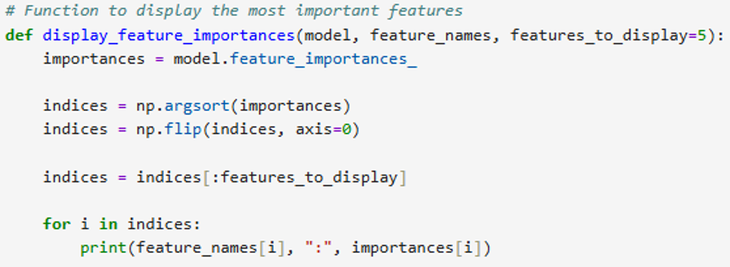
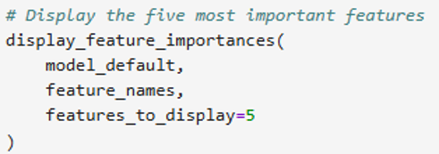
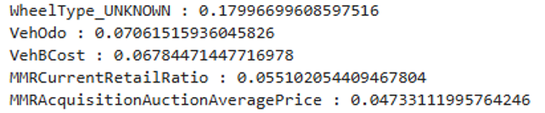
WheelType_UNKNOWN was identified as the attribute with greatest influence in developing the default decision tree with an importance measure of approximately .180. Therefore, it is determined that approximately eighteen percent of the overall weighted reduction in Gini impurity occurred due to splits utilising WheelType_UNKNOWN. This result aligns well with Task 2.1(E), wherein WheelType_UNKNOWN was utilised by the model as the primary split at the root node.
Attributes with slightly lower levels of importance include; VehOdo (.071), VehBCost (.068), MMRCurrentRetailRatio (0.055) and MMRAcquisitionAuctionAveragePrice (0.047). These results indicate that vehicle type availability, vehicle mileage, purchase price and vehicle value data were significant factors in determining classifications made by the default decision tree.
Each feature importance reflects how much a specific feature helped reduce Gini impurity at every level of the decision tree. Thus, a larger importance value indicates a stronger effect on splitting Good/Bad Buy observations. Importantly, these values do not illustrate if a feature will increase or decrease the odds of a bad buy and neither are they indicative of what portion of correct predictions were generated by a given feature.

Task 2.1(G): Report if you see any evidence of model overfitting
To evaluate whether the default decision tree demonstrated evidence of overfitting, the decision tree's performance for both training and testing data sets was evaluated and compared to each other as well as to the level of complexity associated with the resultant tree. A model demonstrates "overfitting" when it fit the training data too closely to demonstrate good generalization abilities to new data.
For the default tree, overfitting evidence is present. In addition to achieving perfect training accuracy (i.e., 100%), the model had an overall test accuracy rate of 81.79%. Therefore, there was a drop-off of about 18.21 percentage points from the training set to the test set. This represents the fact that the tree has been able to closely fit all of the training cases; however, the model did not generalize as well to the test set.
Additional evidence supporting the conclusion that the decision tree is demonstrating overfitting behaviour is provided by examining the level of complexity demonstrated by the tree. There were 6,303 total nodes and 3,152 total leaf nodes/rule in the default tree. The parameters used for creating the tree included setting max_depth=None which would allow the tree to grow indefinitely until one of two stopping criteria are met. Additionally, the minimum number of samples required per node to split (min_samples_leaf) was also set to 1. Finally, ccp_alpha=0.0 indicated that no cost complexity pruning will be performed. These settings resulted in a very large and complex tree that can fit every unique pattern found in the training data set.
This type of behaviour is indicative of models that have little to no bias but a lot of variance. The model fits the training data very well; however, they tend to be overly sensitive to their respective training sample(s) and thus typically do not perform as well when applied to new data.

Task 2.2 - Build Another Decision Tree tuned with GridSearchCV
To reduce the overfitting seen in the default tree model, another Decision Tree was developed utilising GridSearchCV to tune the hyperparameters. GridSearchCV systematically evaluated the different combinations of selected hyper-parameters through cross-validation and determines which combination results in the optimal validation performance. The hyper-parameters examined for tuning are the ones that directly influence the level of complexity of the decision trees.
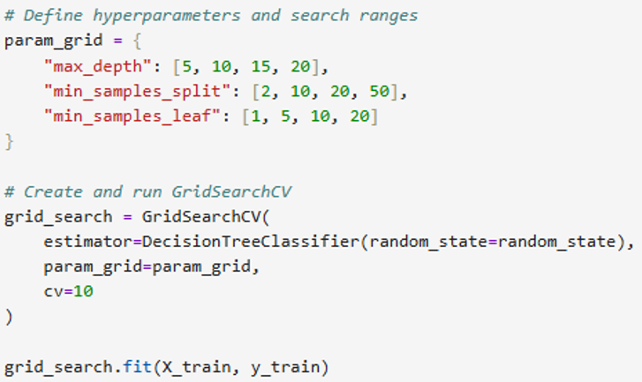
- max_depth was used because there was previously no restriction on how deep the decision tree could grow as specified by max_depth.
- min_samples_split was varied from its default value of 2, since splitting of a node had occurred previously when there were at least two observations
- min_samples_leaf was varied from its default value of 1, since it allows leaves of the default tree to be previously created when they contained a single observation.

The ranges that were selected therefore evaluated a progressive increase in restrictive measures on growing the trees to decrease their model complexity and counteract possible overfitting.
Ten-Fold Cross Validation (cv = 10) was used as this gave a reliable estimation of how well the model performs and retained around 90% of all the train data for model fitting during each fold. There was sufficient train data available (29,002 records), and so still still retained substantial amounts of both training and test data within each fold.

Task 2.2 (A) - What are the optimal parameters for this decision tree? Explain your choice of hyperparameters to search, and the chosen search range(s)?
This section explored whether decision trees can be improved (if overfitting observed in the default tree can be reduced) through GridSearchCV by finding optimal combinations of parameters that affect the complexity of trees. Max_depth, min_samples_split and min_samples_leaf were previously controlled due to their influence on the development of tree complexity. the search ranges for these parameters were set to compare them with the default settings
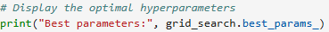
Which yielded:
The initial GridSearchCV found max_depth = 5, min_samples_leaf = 5, and min_samples_split = 2 to be the best combination. Since max_depth = 5 was the smallest max_depth in the initial search space it is possible that a shorter tree would produce better results during cross-validation. As such, a second GridSearchCV was run utilising max_depth values from 2-6, and values around the initially determined min_samples_split and min_samples_leaf values.
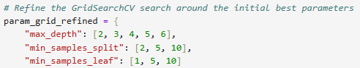
Which yielded:
In the second GridSearchCV max_depth = 4, min_samples_leaf = 1, and min_samples_split = 10 produced the best combination and resulted in an average cross validation accuracy of approximately 89.89% when splitting into 10 groups. Compared to no restriction on max_depth on the default model, max_depth = 4 provides a significant limitation on tree growth. min_samples_split = 10 indicates that at least 10 observations must exist within a node prior to additional splits. Lastly, retaining the default min_samples_leaf = 1 does not limit leaf size. These parameters generated the greatest average cross validation accuracy relative to all parameter combinations in the second GridSearchCV.

Task 2.2 (B) - What is the classification accuracy on the training and test datasets?
The performance of the optimised decision tree was calculated again based on the accuracy on both the training and test datasets. This comparison provided insight into how well the optimised model can generalise unseen data.
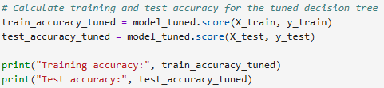
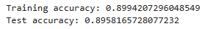
The trained decision tree was able to achieve a training accuracy of 89.94% and a test accuracy of 89.58%. The test accuracy was only slightly less than the training accuracy; approximately 0.36 percent, showing consistency across both the training data and unseen test data. These results indicate that that model is well-generalised.
In comparison, the default decision tree achieved a training accuracy of 100%, and a test accuracy of 81.79%, thus the tuning resulted in reducing the gap between the training and test accuracy whilst at the same time improving the test accuracy by approximately 7.79% compared to the default decision tree. In this case, the loss in training accuracy is not inherently negative as the default model was shown to fit too tightly to the training data. Therefore, the tuning of the model demonstrated significantly better generalisation to unseen observations.

Task 2.2 (C) - What is the size of the chosen tree (number of nodes and rules)?
The size and complexity of the optimised decision tree was analysed by identifying the total number of nodes, number of leaf nodes and number of decision rules.
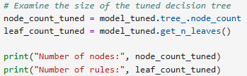
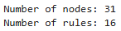
The optimized decision tree has 31 total nodes and 16 terminal leaf nodes, which equates to 16 decision rules. This is a considerable decrease in complexity when comparing to the default decision tree. Our default decision tree had 6,303 total nodes and 3,152 decision rules. These results corresponded well with the hyperparameters identified by GridSearchCV that would best optimize the decision tree, especially those hyperparameters that restricted the maximum depth of the tree (max_depth = 4), and required a minimum of 10 observations per node prior to splitting (min_samples_split = 10).

The substantially smaller tree is also consistent with the improved generalisation observed in Task 2.2(B), where training and test accuracy were very similar. This suggests that restricting tree complexity reduced the default model's tendency to fit highly specific patterns in the training data.

Task 2.2 (D) - Which variable is used for the first split? What are the variables that are used for the second split?
Following the same process as Task 2.1(E) the first and second splits of the optimised decision tree were plotted.

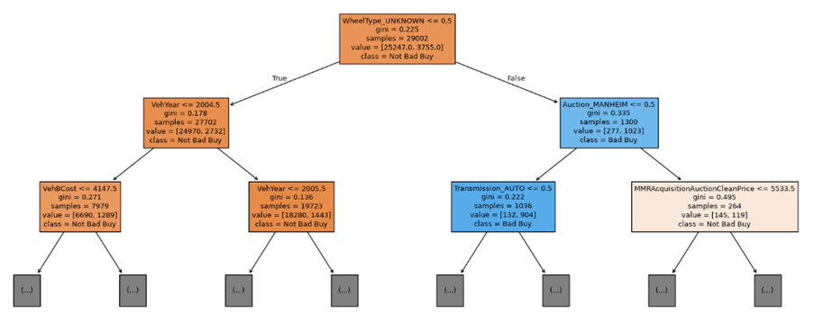
WheelType_Unknown was the variable selected for the first split of the tuned decision tree at a threshold of 0.5.
At the second level, the model selected different variables depending on the outcome of the first split. For vehicles with a known wheel type, the second split used VehYear at a threshold of 2004.5. For vehicles with an unknown wheel type, the second split used Auction_MANHEIM at a threshold of 0.5.
These first and second splits are the same as those generated by the default decision tree in Task 2.1(E). This indicates that tuning did not change the variables the model considered most useful for its initial separation of the observations. Instead, the major effect of tuning was likely due to the restriction of subsequent growth of the tree, reducing it from 6,303 nodes and 3,152 rules to 31 nodes and 16 rules.

Task 2.2 (E) - What are the five important variables in building the tree?
Following the same process as Task 2.1(F) the five most important features of the optimised decision tree was produced.
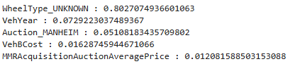
The updated results showed that WheelType_UNKNOWN had the greatest influence in determining the splits for the tuned decision tree. It had a score of around .803 which indicated that about 80.3% of the total weighted reduction in Gini Impurity in the optimised decision tree came from splits based on WheelType_UNKNOWN. This matches task 2.1(F), as this was also the feature chosen for the first split.
VehYear (.073) , Auction_MANHEIM (.051), VehBCost ( .016), and MMRAcquisitionAuctionAveragePrice (.012) were the next four features with high enough importance to make the list. Again, both VehYear and Auction_MANHEIM were also part of the tree structure shown in task 2.2(D) as they made up two of the three second level splits.
Relative to the default decision tree, the optimised tree assigned substantially more weight to WheelType_UNKNOWN. WheelType UNKNOWN previously had an importance score of approximately .180 which increased to 0.803 in the optimised tree. Since the optimised tree was pruned by GridSearchCV from from 6,303 Nodes to 31 Nodes, there were fewer features contributing to the tree’s total impurity reduction. As a result, early splits accounted for a much greater proportion of the model’s overall feature importance.

Task 2.2 (F) - Report if you see any evidence of model overfitting
A significant difference between training and test accuracy indicates that the model is overfitting and had fitted the training data more closely than it could generalise to unseen observations.
The optimised decision tree produced a training accuracy of 89.94% whereas producing a test accuracy of 89.58%, which translate to approximately a 0.36% reduction. As such there is very little evidence of overfitting, as the model performed equally well on the training set and the unseen test dataset.
This represents a significantly greater increase than the default decision tree which produced a training accuracy of 100% whilst only achieving a test accuracy of 81.79%. There was a gap of just under 18.21% between these values. In addition, GridSearchCV reduced the number of nodes from 6,303 to 31 and the number of rules from 3,152 to 16. Consequently, the tuned version of the model has a substantially smaller number of nodes/rules than the original model. The results suggest that the tuned version of the model demonstrated improved generalisation when applied to previously unseen data. Therefore, the conclusion is that the tuning process has effectively eliminated overfitting evident that was originally present in the default model.

Task 2.3 – Comparing Default vs GridSearchCV tree models
What is the significant difference between these two decision tree models – default (Task 2.1) and using GridSearchCV (Task 2.2)? How do they compare performance-wise? Produce the ROC curve for both DTs. Explain why those changes may have happened.
It was established earlier that the optimised decision tree outperformed the default decision tree in terms of its overall performance and generalisation. The default tree achieved 100% training accuracy but only 81.79% test accuracy resulting in a difference of roughly 18.21% and showed signs of overfitting. Conversely, the tuned model produced 89.94% training accuracy and 89.58% test accuracy for a difference of approximately .36%.
Although tuning resulted in a reduction in training accuracy, there was a nearly eight-fold increase in test accuracy (approximately 7.79%) indicating significantly superior performance when dealing with previously unknown data.
There were substantial differences between the two models regarding their structural complexity. The default tree contained 6,303 nodes and 3,152 rules while the tuned tree contained only 31 nodes and 16 rules. As a result of using GridSearchCV to select optimal parameters, max_depth = 4, min_samples_split = 10 and min_samples_leaf = 1 were chosen which greatly restricted the growth of the tree relative to the unrestricted nature of the default model. By limiting the number of levels available to grow into, the amount of overly complex rules that could potentially be generated due to fitting too many unique patterns and/or random noise in the training dataset was dramatically decreased. this resulted in the tuned model having lower variance and exhibiting less overfitting behaviour than the default model which ultimately contributed to its substantially better performance.

The default and optimised decision trees were compared to see what effect hyperparameter tuning had on model complexity, performance generalisation of unseen data. To permit this analysis, ROC-AUC Analysis was used to compare each model’s ability to discriminate between IsBadBuy = 0 and IsBadBuy = 1 across different thresholds for classification.
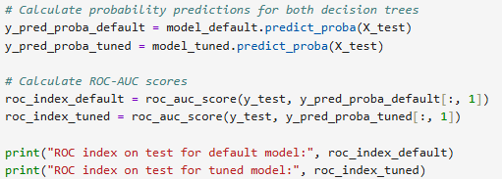
Which yields:
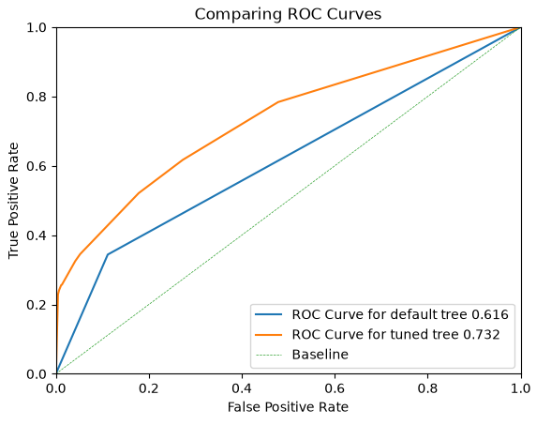
Further evidence supporting the improvement in performance can be seen through the application of Receiver Operator Characteristics (ROC). While the default decision tree yielded an AUC value of 0.616, the optimised decision tree produced an AUC value of 0.732. Moreover, the tuned model’s ROC curve tended to lie above the default model’s ROC curve across most classification thresholds suggesting a better trade off between the true positive rate and the false positive rate when varying the classification thresholds. Therefore, based upon the AUC values, it appears that the tuned decision tree can make a better distinction between “Bad Buy” and “Not Bad Buy”.
In conclusion, based on performance metrics including, discrimination between target classes, accuracy on unseen test datasets, degree of overfitting exhibited and simplicity/interpretability of resultant trees, the optimised decision tree represents the superior performing model.

Task 2.4 – Cars most likely to be ‘kicks’
From the better model, can you provide the characteristics of cars most likely to be ‘kicks’? If it is hard to comprehend, discuss why.
The optimised decision tree was chosen to find the features that will identify the characteristics of vehicles which are most likely to be identified as "kicks" (IsBadBuy = 1). As shown in Task 2.3, the optimised decision tree gave better test accuracy, better ROC-AUC scores and generalisation than the default decision tree. Reviewing the decision path from the root node to each of these leaves provided a set of vehicle characteristics that represented the greatest expected probability of a vehicle being a kick.
To do this, the entire optimised decision tree was plotted. This was possible to graph as the optimised decision tree had its maximum depth restricted to the optimised value of 4.
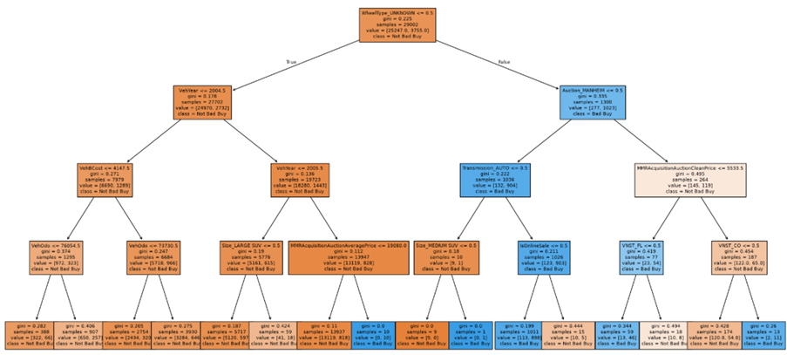
The plot of the decision tree shows that WheelType_UNKNOWN was found to be the strongest characteristic associated with a vehicle being classified as a "kick." Of the 1,300 observations in the training data with an unknown wheel type, there were 1,023 (78.7%) that were classified as Bad Buys, while Bad Buys comprised only 12.9% of all the observations in the training data. The results are consistent with WheelType UNKNOWN also being the feature with the highest importance in terms of classification using the tuned model.
The worst risk combination existed for vehicles with an unknown wheel type, not listed on MANHEIM, automatic transmission, and not sold on-line. In this case, there were 881 out of 899 observations (98.0%) that were classified as Bad Buys.
Other characteristics include:
- Auction provider – particularly whether the vehicle was auctioned through MANHEIM.
- Transmission type – Transmission_AUTO further separated vehicles within the high-risk unknown-wheel-type group.– Transmission_AUTO further separated vehicles within the high-risk unknown-wheel-type group.
- Online sale status – IsOnlineSale further differentiated Bad Buy risk within this group.
- Vehicle year – VehYear was an important discriminator among vehicles with a known wheel type.
- Vehicle cost and odometer reading – VehBCost and VehOdo further separated risk for vehicles with a known wheel type.
- State – VNST_FL and VNST_CO were used to further differentiate vehicles within one auction-provider branch.
Some additional factors included:
- Auction provider – specifically whether or not the vehicle was auctioned through MANHEIM.
- Transmission type – Transmission_AUTO also further divided up vehicles within the high-risk unknown-wheel-type category. – Transmission_AUTO also further divided up vehicles within the high-risk unknown-wheel-type category.
- Whether or not the vehicle was sold on-line – IsOnlineSale further discriminated against Bad Buy risk within this category.
- The age of the vehicle – VehYear was another factor that discriminated among vehicles with a known wheel type.
- The cost and mileage of the vehicle – VehBCost and VehOdo further distinguished risk among vehicles with a known wheel type.
- The State in which the vehicle was located – VNST_FL (Florida) and VNST_CO (Colorado) were used to further discriminate among vehicles in one auction provider branch.
In summary, the optimised decision tree shows several characteristics of vehicles that can be interpreted relative to their likelihood of being a "kick". However, these characteristics represent predictive associations rather than causation.

Task 3 – Regression Modelling

Task 3.1 – Processing the dataset for regression modelling
Describe what additional processing was required on this dataset to be used in regression modelling. List the variables that need further processing and provide details of the processing.
Logistic regression can be used as a viable model because IsBadBuy is binary nominal (Bad Buy = 1 or Not Bad Buy = 0). As described in Module 3.11, logistic regression can be applied since it produces predictions using the sigmoid function based upon the probability of an observation being classified into a specific category.
Most preprocessing was completed in Task 1 and 2. To support logistic regression, some variables were required to undergo standardisation in order to be compared as their numerical values were measured in different units.
The numerical variables that required standardisation were:
- VehYear;
- VehicleAge;
- VehOdo;
- VehBCost;
- MMR Variables; and
- OHE Variables.
Standardisation was fitted using the training data only and then applied to both training and test data to avoid information from the test set influencing model training.

Methodology for Standardisation
Step 1: Display predictor scaling before standardisation
To show the large difference in scales among the predictors, the minimum, maximum, mean, and standard deviation values for the first five predictors in the training dataset were calculated and displayed.

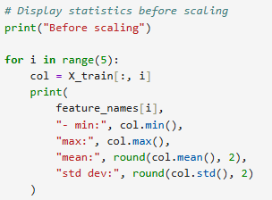
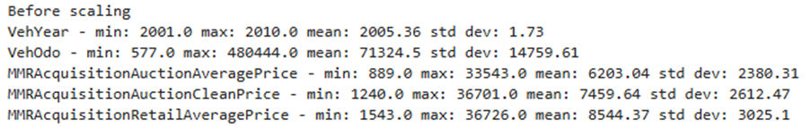
As can be seen in the results table above, there are significant differences in scale among these predictors. For example, VehYear had a mean of 2005.36 and a standard deviation of 1.73. On the other hand, VehOdo had a mean of 71,324.5 and a standard deviation of 14,759.61. Similarly, the MMR value-based predictor variables were also significantly different in terms of scale.
Step 2: Standardise training and test data
The data is normalised by applying a standardiser (StandardScaler) to all the predictor variable(s). First, StandardScaler is fitted to the training set (X_train) using fit_transform(). In doing this, it calculates the mean and std for each predictor, to be able to scale X_train appropriately. The same trained scaler is then fitted to X_test using transform() to obtain the scaled version of X_test. In this way, the scaling is based on the training set alone and does therefore not suffer from data leakage
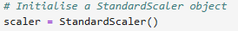
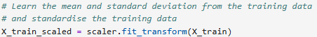
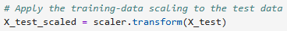
Step 3: Verify standardisation
Finally, the same statistics from step 1 are again executed and displayed to verify that the standardization has transformed the first 5 predictor variables in X_train.
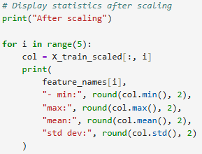
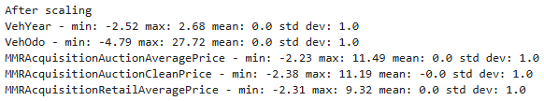
As expected, after applying StandardScaler, each of the first five predictor variables now have mean of approximately zero and standard deviations equal to 1, indicating that StandardScaler successfully scaled the predictor variables so that they are on similar scales. The resulting X_train_scaled and X_test_scaled data frames were subsequently used for logistic regression modelling.

Task 3.2 – Regression Modelling with GridSearchCV
Build a regression model tuned with GridSearchCV
GridSearchCV was used to develop the optimised regression model by identifying which combination of hyperparameters would produce the highest cross-validated performance. Aligning to the module 3 practical, the regularisation parameter C was logarithmically tuned. Cross validation value was set at 10.

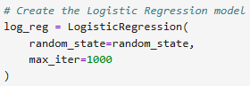
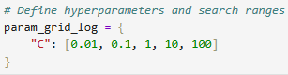
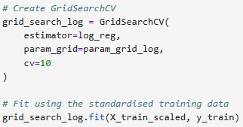

Task 3.2(A) – Regression Function
Name the Regression function used
The logistic regression function LogisticRegression() from Scikit-learn’s linear_model was used. This type of function is ideal for use when the target variable is binary, so this applies appropriately to our target variable IsBadBuy.

Task 3.2(B) – Optimal Parameters
What are the optimal parameters for this regression model? Explain your choice of hyperparameters to search, and the chosen search range(s)?
The regularisation parameter C was selected for optimisation since it determines the amount of regularisation applied in logistic regression models. Smaller values of C result in more regularisation which reduces model complexity, helping to prevent overfitting and improve generalisation to unseen data. Conversely, larger values of C apply weaker regularisation. The choice of a range of C values (from 0.01 through to 100) allows testing of progressively less strong regularisation across different orders of magnitude. C’s permitted ranges can reasonably vary by orders of magnitude. For this reason, testing only a small range of values such as 0.5, 1 and 1.5 would explore only a narrow range of regularisation strengths.
Cross-validation was employed at ten folds to provide an improved estimate of how accurately the model will perform relative to cross-validation at just one-fold. This corresponds to the method of tuning described within the module 3 practical.
The best values for the hyperparameter C is they displayed:
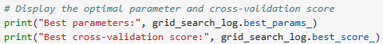
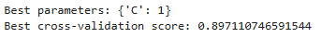
Using GridSearchCV, the optimal value for the regularisation parameter was C = 1, yielding a best 10-fold cross-validation accuracy of approximately 89.71 %. This implies that the value of C = 1.0 gave the "best" trade-off between applying regularisation and producing high cross-validation accuracy amongst those values tested (i.e., 0.01, 0.1, 1.0, 10.0, and 100.0). As such, the logistic regression model employing C = 1.0, identified by GridSearchCV, will be used throughout subsequent analyses.

Task 3.2(C) – Variables Used
Report the variables that are included in the regression model.
Variables that were input into the tuned Logistic Regression model were assessed to confirm the final predictor set that was developed from preprocessing and OHE.
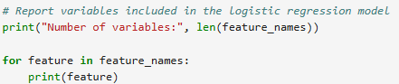
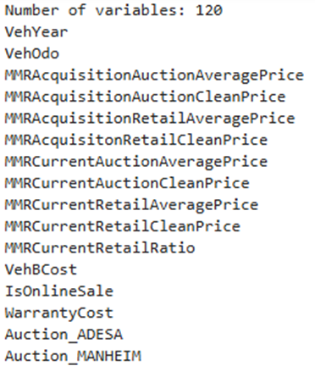
The logistic regression model had 120 predictor variables. It contained all the retained numerical predictors (vehicle year, odometer, MMR valuation, vehicle cost; warranty Cost) as well as all the categorical predictors that were previously encoded using one-hot encoding.

Task 3.2(D) – Top 5 Important Variables
Report the top-5 important variables (in order) in the model.

The five most important variables from the optimized logistic regression model are those whose model coefficients had the largest absolute values. Both positive and negative coefficients may have high absolute values and therefore suggest a strong relationship with the output prediction. Because all predictors were standardised before modelling, the relative size of each predictor's coefficients was able to be compared.

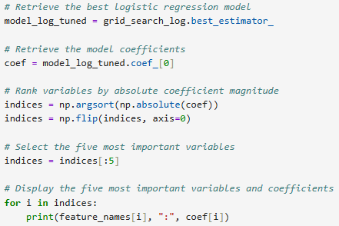
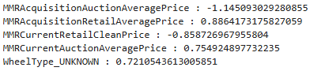
MMRAcquisitionAuctionAveragePrice (the price for which vehicles sold at auction) was ranked as the most important variable; this is followed by MMRAcquisitionRetailAveragePrice (vehicles' average retail prices), MMRCurrentRetailCleanPrice (clean retail price for vehicles), MMRCurrentAuctionAveragePrice (average price for vehicles at current auctions) and WheelType_UNKNOWN.
Four out of the five most important variables are related to MMR valuations indicating that the vehicle valuation data had an important effect on the logistic regression model. WheelType_UNKNOWN is the one categorical predictor in the top five, and it is also shown to be important by both the default decision tree model and the optimised decision tree model. The sign of each coefficient indicates whether there is a positive or negative association with the log odds of a Bad Buy. We used only the size of each predictor's absolute value when determining its place in our ranking.

Task 3.2(E) – Accuracy of Training and Test Datasets
What is the classification accuracy on training and test datasets?
The classification accuracy of the tuned logistic regression model was evaluated on both the training and test datasets. Comparing these results provides an indication of how well the fitted model performs on the training observations and generalises to unseen test data.
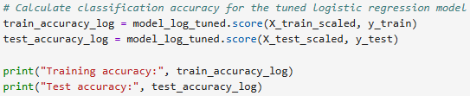
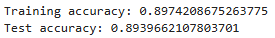
A classification accuracy of approximately 89.74% was obtained for the training data, while an accuracy of 89.40% was obtained for the test data. That the same level of classification accuracy was achieved by the model for both training and test data would indicate that the model maintains its ability to predict accurately with new data. However, it can be seen that there are very slight differences in accuracy which will be investigated further in Task 3.2(F) where potential overfitting is assessed.

Task 3.2(F) – Overfitting Conclusions
Report any sign of overfitting.
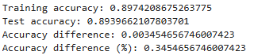
The tuned logistic regression model showed very few signs of overfitting. This is supported by the fact that whilst the trained logistic regression model has a training accuracy of 89.74%, the test dataset had an accuracy of 89.40%, which equates to a difference of only approximately 0.35 percentage points. In addition to this small difference in the accuracies, it can be seen that both training and testing accuracy are quite high; therefore the overall good performance of the model on the unseen test data set suggests that the model does generalise as well as fits the training data.

Task 3.3 – Minimum variable set Regression Model

Task 3.3(A) – Dimensionality Reduction and Feature Selection
The use of Recursive Feature Elimination with Cross Validation (RFECV) allowed for the reduction in the number of independent variables in the logistic regression model.
Recursive elimination is a process where each time one variable is eliminated it produces new models and then those are evaluated using cross validation. This allows for identification of an optimal combination of predictor variables that has high predictive ability.
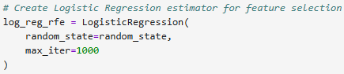
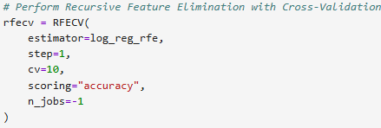
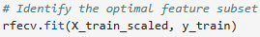
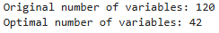
The application of RFECV resulted in the original 120 variables being reduced to 42 variables by eliminating 78 variables. This type of dimensionality reduction was beneficial since the reduced model performed similarly on the test data as did the full model. The reduced model produced a test accuracy score of 89.43%, which compares to a test accuracy score of 89.40% for the full model. Therefore, the elimination of approximately 65% of the variables retained virtually identical performance to the full model. This resulted in a much smaller set of features than before without reducing the overall performance of the model.

Task 3.3(B) – Variables Included in the Reduced Model
RFECV retained a total of 42 variables to form the reduced model. Those variables were determined based on the support_ attribute, and that attribute identifies those features that are used in the reduced model.
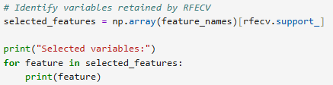
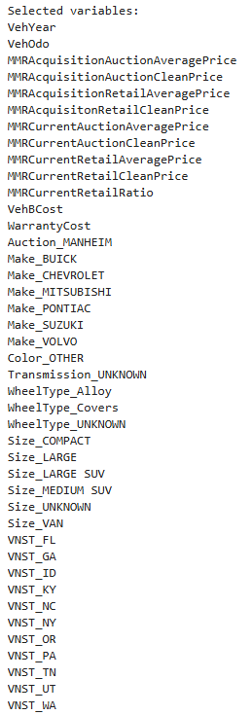
Of the 120 predictors available in the full data set, RFECV chose to retain 42. Of these retained predictors, there was some information about vehicles (such as VehYear, VehOdo, VehBCost and WarrantyCost) along with MMR valuation attributes. In addition, there were one-hot encoded predictor values for auction providers, vehicle makes, wheels, sizes of vehicles, and states. RFECV removed the remainder of the predictors.

Task 3.3(C) – Classification Accuracy
After applying feature reduction, the logistic regression model was retuned using utilizing GridSearchCV with the same logarithmically scaled C parameter search space. This process also utilised the same 10-fold CV method as originally applied. By doing so, both the full (120 features) and reduced (42 features) models were tuned similarly for evaluation.
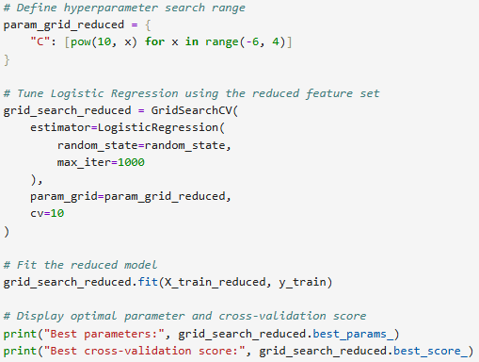
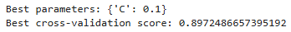
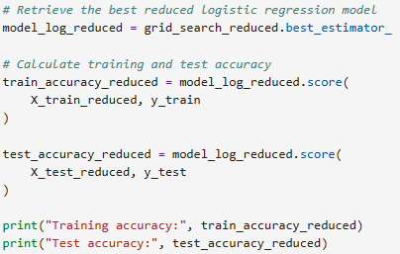
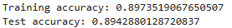

The parameters chosen through GridSearchCV resulted in the selection of C = 0.1 for the reduced model. The reduced model performed at an approximate level of 89.74% on the training data and at an approximate level of 89.43% on the testing data. These levels of performance are roughly equivalent to those found within the full model which demonstrated similar levels of performance on the training (89.74%) and testing (89.40%) datasets. Therefore, it can be concluded that the application of feature reduction from 120 down to 42 variables had no negative impact upon the overall classification performance.

Task 3.3(D) – Overfitting
Overfitting potential in the reduced model was evaluated through comparisons of both models' training vs. test (unseen) classification accuracies.
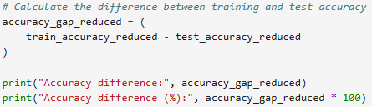
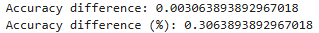

The results show little indication of overfitting for the reduced model. It had an accuracy of about 89.74% on the training set while it had an accuracy of about 89.43% on the test (unseen data), representing a 0.3% difference. Therefore, this is evidence that the reduced model generalised well from seen data to unseen data. The difference is even less than what was observed by the full model where the difference was close to .35%.

Task 3.4
ROC curves were created for both the full logistic regression model and the RFECV reduced logistic regression model to show how each model can distinguish between bad buy and not bad buy observations at different classification thresholds. Predicted probabilities were calculated with predict_proba() and Area under the curve (AUC) values were obtained through roc_auc_score() along with the roc curve itself via roc_curve().
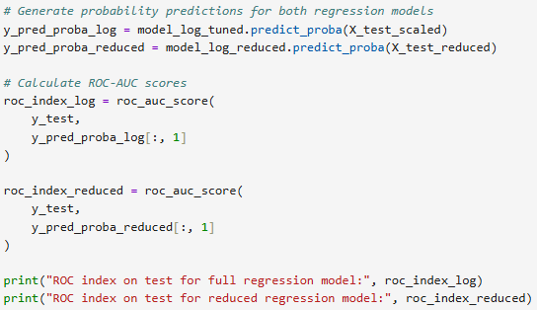
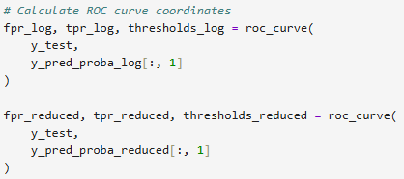
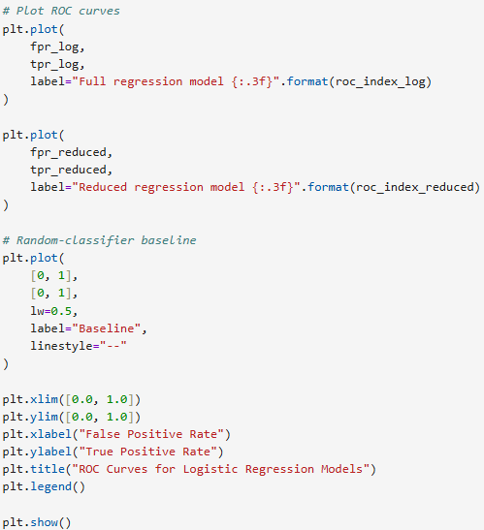
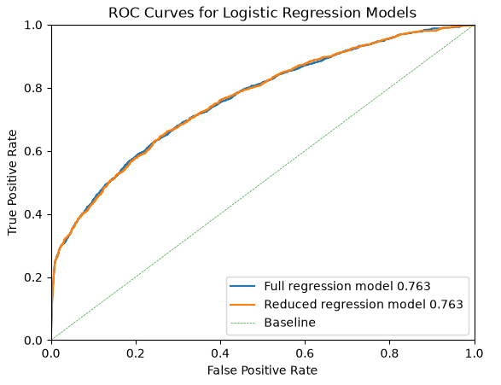
Both models achieved almost identically high values on the ROC-AUC score; the full logistic regression model achieved a value of .7630, while the reduced model achieved a slightly lower value of .7629. Because they are virtually indistinguishable, we know that these two models have nearly equal discrimination ability for distinguishing between bad buy and not bad buy. Also, because both models stay above the baseline line, we can conclude that they both provide much greater discrimination than would occur randomly.
While there was a very slight difference in the AUC scores (the full model had a slightly higher score), it was minimal. Additionally, although the full model had many more features than did the reduced model (120 vs. 42), it actually had a slightly lower test accuracy (.8940 vs. .8943). For this reason, we will consider the reduced model to be the best model, since it achieved practically identical performance to that of the full model, but with far fewer features. 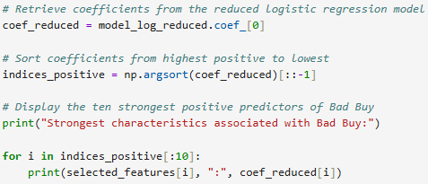
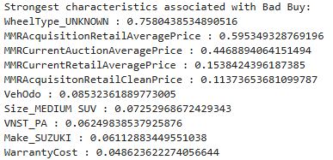
The positive coefficients of the reduced logistic regression model were examined to determine which characteristics that were most positively associated with an increased probability that IsBadBuy = 1. We found that wheeltype_unknown (coefficient of 0.758) was the most positively correlated predictor, which means that vehicles that have unknown wheels were most positively associated with being classified as Bad Buys. Some additional positively correlated predictors include some of the MMR valuation measures higher odometer readings, Size_Medium_SUV, VNST_PA, Make_Suzuki and higher warranty cost.
These characteristics should only be interpreted as associations rather than causes. Specifically, many related MMR variables were included in the model, which makes their individual effects harder to interpret independently. Similarly, an unknown type does not necessarily cause a vehicle to be classified as a bad buy, but may instead represent characteristics of that vehicle or lack of information provided in auction listings.
In general, RFECV made significant simplifications to the original logistic regression model without suffering any material losses in predictive performance. Essentially identical roc curves demonstrate that reducing the feature set from 120 to 42 features resulted in practically no loss of discrimination ability. The reduced model indicates that unknown type was strongest single characteristic associated with kicks together with

Task 4 – Predictive Modelling Using Neural Networks

Task 4.1 – Processing the Dataset for Neural Network Modelling
Most data cleaning such as handling missing values, dropping non-predictive variables, and one-hot encoding categorical features—was completed in Tasks 1 to 3. The same training and test splits were retained to maintain a consistent baseline.
Additional preprocessing was required specifically for neural network training:
StandardScaler: Neural networks are sensitive to the differences in the scale of input variables. The scaler was fitted using fit_transform()
# Standadise the predictor variables. #
scaler = StandardScaler()
X_train_scaled = scaler.fit_transform(X_train)
X_test_scaled = scaler.transform(X_test)
Leakage Prevention: The scaler was fitted strictly on X_train using fit_transform() and then applied to X_test using transform(). Fitting across the entire dataset prior to splitting would constitute data leakage by exposing test distribution parameters to the training data.

Task 4.2 – Neural Network Model Using All Predictor Variables
An initial multi-layer perceptron (MLPClassifier) was constructed using all 120 predictor variables. 10-fold cross-validation with GridSearchCV optimized for ROC-AUC rather than raw accuracy.
# Task 4.2 - Neural Network - All Predictor Variables. #
# Create neural network model.
nn_full = MLPClassifier(
random_state=42,
max_iter=500
)
Class Imbalance: Roughly 87% of observations belong to the majority class (IsBadBuy = 0). A naive model predicting all zeros hits 87% accuracy while being commercially useless. ROC-AUC evaluates ranking discrimination across all classification thresholds regardless of base rates.
# Prepare the grid search with cross validation. #
grid_full = GridSearchCV(
estimator=nn_full,
param_grid=param_grid_full,
cv=10,
scoring='roc_auc',
n_jobs=-1
)

Task 4.2(A) – Parameters and Hyperparameter Search
Base Settings:
- max_iter = 500; and
random_state = 42.
Tuning Grid:
Hyperparameter | Values Tested
hidden_layer_sizes | (50,),  (100,),  (50, 25),  (100, 50)
activation | ['relu', 'tanh'],
alpha | [0.0001, 0.001, 0.01],
learning_rate_init | [0.001, 0.01]
Best parameters for NN1:
- Best parameters:
- {'activation': 'relu', 'alpha': 0.01, 'hidden_layer_sizes': (100,), 'learning_rate_init': 0.01}
- Best cross-validation ROC-AUC: 0.7103

Task 4.2(B) – Classification Accuracy
- Training accuracy: 0.9076
- Test accuracy: 0.8879
There was a gap of 1.97 % between training and testing datasets. Given the ~87% majority in not IsBadBuy, these figures mask the model's ability to discriminate classes, reinforcing the necessity of ROC-AUC.

Task 4.2(C) – Convergence
- Iterations: 96
- Final loss: 0.2796941603034794
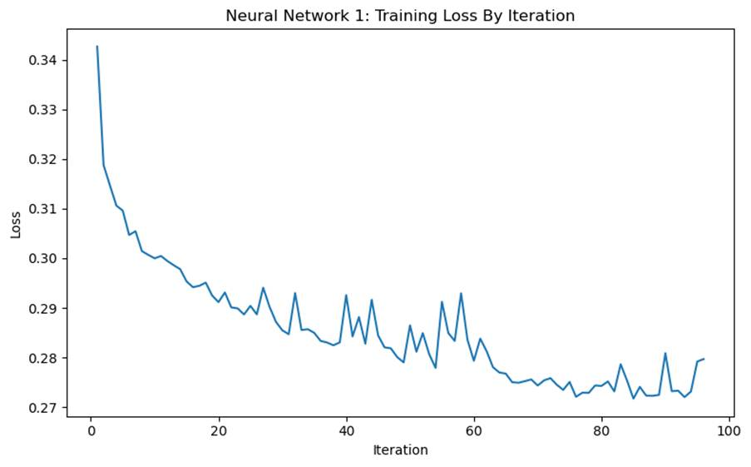
The training loss curve flattened steadily, and the optimiser triggered early stopping because the rate of error improvement was too low rather than hitting the 500-iteration ceiling. The model converged cleanly.

Task 4.2(D) – Overfitting
Assessment: Mild overfitting is present.
Evidence: The 1.97% drop in test accuracy combined with a modest test ROC-AUC (0.7266). The test performance degraded slightly (2 %) which suggestes this mostly influenced by the 87 % imbalance for not IsBadBuy and reinforces the need for the AUC.
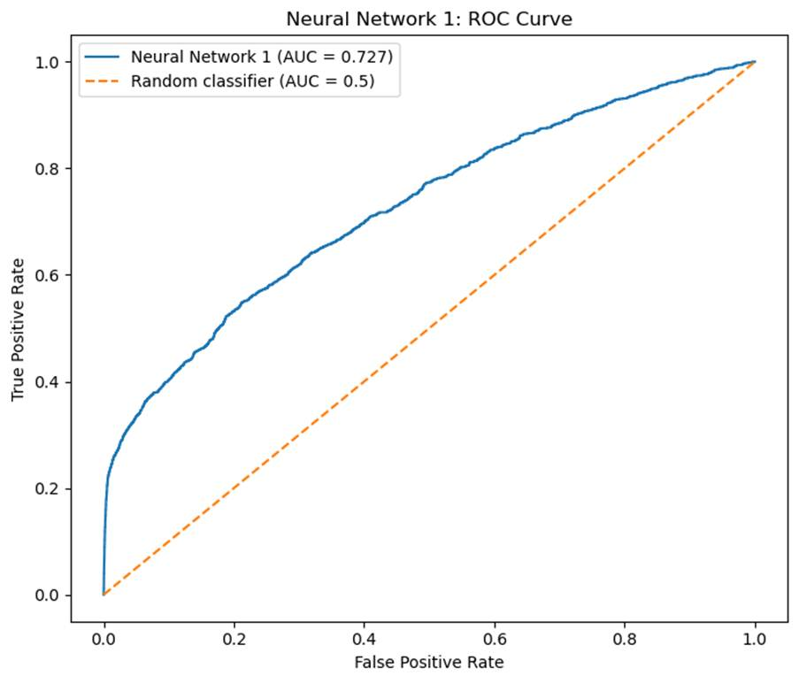

Task 4.3 – Neural Network Model Using the Reduced Feature Set
A reduction of features was conducted using the top 5 features identified by Task 2’s decision tree feature importance:
# Features selected using Decision tree feature importance. #
selected_features = [
'WheelType_UNKNOWN',
'VehYear',
'Auction_MANHEIM',
'VehBCost',
'MMRAcquisitionAuctionAveragePrice'
]

# Create reduced training and test datasets. #
X_train_reduced = X_train[selected_features].copy()
X_test_reduced = X_test[selected_features].copy()

# Check dimensions of reduced datasets. #
print("Reduced training data:", X_train_reduced.shape)
print("Reduced test data:", X_test_reduced.shape)

X_train_reduced.head()
- WheelType_UNKNOWN
- VehYear
- Auction_MANHEIM
- VehBCost
- MMRAcquisitionAuctionAveragePrice
Features were reduced by ~95.8% (from 120 to 5).
A separate StandardScaler was fit to the 5-feature training set and transformed onto the test set.
# Standardise the reduced predictor variables. #
scaler_reduced = StandardScaler()
X_train_reduced_scaled = scaler_reduced.fit_transform(
X_train_reduced
)

X_test_reduced_scaled = scaler_reduced.transform(
X_test_reduced
)

# Check dimensions #
print("Scaled reduced training data:", X_train_reduced_scaled.shape)
print("Scaled reduced test data:", X_test_reduced_scaled.shape)

The identical 10-fold CV GridSearchCV space was evaluated on NN2.
grid_reduced = GridSearchCV(
estimator=nn_reduced,
param_grid=param_grid_reduced,
cv=10,
scoring='roc_auc',
n_jobs=-1
)

Task 4.3(A) – Feature Selection & Architecture Changes
Outcome: Feature selection strongly favoured the model. By reducing the features from 120 to 5 much of the noise within the dataset was trimmed. The 120 inputs had to apply an aggressive learning rate of 0.01 because of the rough optimisation surface. Having to deal with only 5 features smoothed out the optimisation surface and allowed a more precise learning rate of 0.001.
NN1 vs NN2 Architectural Comparison:
Metric / Setting | NN1 (All 120 Features) | NN2 (Reduced 5 Features)
Input Features | 120 | 5
Hidden Layer Shape | (100,) | (50,)
Activation | relu | tanh
Alpha (L2 Penalty) | 0.01 | 0.001
Initial Learning Rate | 0.01 | 0.001
CV ROC-AUC | 0.7103 | 0.7517

Trimming 115 noisy inputs allowed a 50% smaller hidden layer to extract stronger predictive signals, increasing the cross-validated ROC-AUC from 0.7103 to 0.7517.

Task 4.3(B) – Classification Accuracy Comparison
- NN1 (Full):
  - Training accuracy: 0.9076
  - Test accuracy: 0.8879
  - Gap: 1.97 %
- NN2 (Reduced):
  - Training accuracy: 0.8978
  - Test accuracy: 0.8958
  - Gap: 0.20 %
Training accuracy fell slightly (-0.98 %), but test accuracy rose (+0.79 %). Sacrificing in-sample features directly boosted test samples accuracy.

Task 4.3(C) – Number of Training Iterations
- NN1
  - Iterations: 96
  - Final loss: 0.2796941603034794
- NN2:
  - Iterations: 39
  - Final loss: 0.3114856888441988
- Convergence: Full convergence achieved at iteration 39 which is well before the 500 limit.

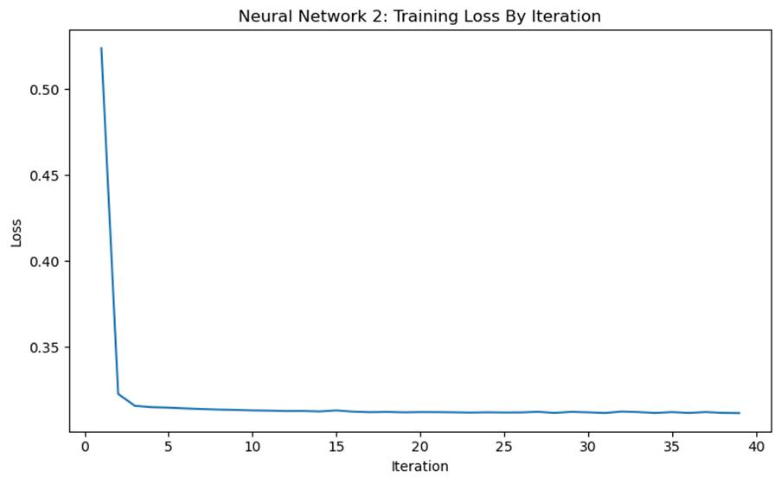A 59 % reduction in required iterations. Fewer features lead to a smoother surface that allowed the loss landscape to be navigated much faster. The higher final loss in NN2 is standard regularised behaviour: it avoided fitting noise (bumps) and yielded superior test metrics.

Task 4.3(D) – Overfitting
Overfitting: Virtually eliminated. The test-to-train gap narrowed to 0.20 pp.
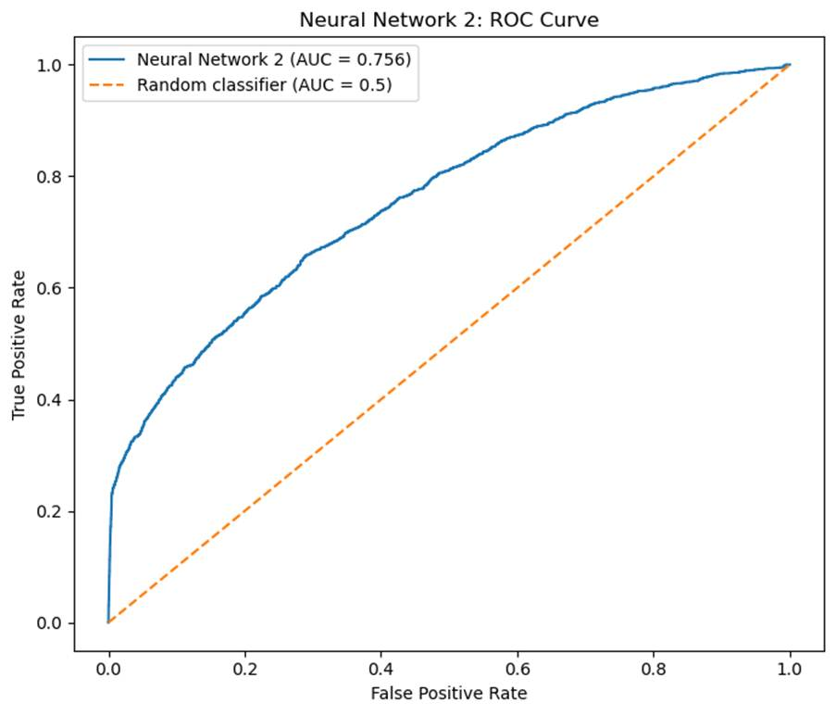

Task 4.4 – ROC Curve Comparison and Characteristics of Kicks
Performance Summary:
Model | Inputs | Train Acc. | Test Acc. | Test ROC-AUC
NN1 (Full) | 120 | 90.76% | 88.79% | 0.7266
NN2 (Reduced) | 5 | 89.78% | 89.58% | 0.7563

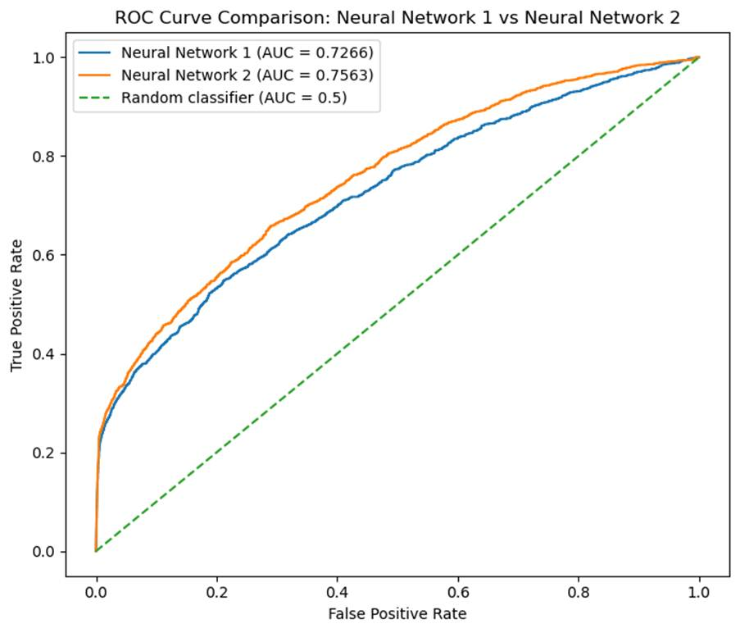
NN2 is better NN1 across the following metrics: higher test accuracy (+0.79 %), higher test ROC-AUC (+0.0297), negligible overfitting gap and faster training.

Characteristics of Kicks & Interpretability Limitations
Extracting direct kick characteristics from NN2 illustrates a classic "black-box" trade-off:
- Non-Linear Entanglement:
  - Unlike logistic regression (which gives linear log-odds coefficients) or decision trees (which provide explicit if-then split paths), a neural network processes inputs through hidden layer transformations (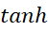) and dense weight matrices.
- Feature Interactions:
  - The impact of VehBCost or VehYear variables on kick probability is volatile because the direction can go either way and are heavily dependent on the simultaneous states of the other inputs.
- Context of Feature Selection:
  - While NN2 confirms that WheelType_UNKNOWN, VehYear, Auction_MANHEIM, VehBCost, and MMRAcquisitionAuctionAveragePrice drive kick risk, we rely on the upstream Task 2 tree to establish directionality (e.g., vehicles with missing/unknown wheel records, older models, and anomalies between purchase cost and market average price carry substantially higher lemon risk).

Overall Task 4 Conclusion
Dropping 115 variables improved test ROC-AUC from 0.7266 to 0.7563 while slashing convergence time by about 59 %. Neural networks on tabular data can be susceptible to noise therefore excluding uninformative one-hot features allowed NN2 to reach parity with Task 3's reduced logistic regression (~0.763), providing a solid foundation for the final Task 5 multi-model comparison.

